**Big Barn Bash**

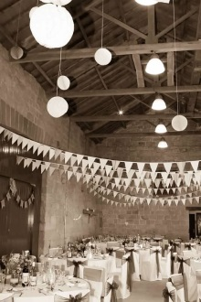

Castle Farm is the perfect setting for your wedding, event or special occasion.

As well as being a working farm with beautiful rolling countryside and a peaceful, tranquil setting as your backdrop. Castle Farm offers you an ideal location to guarantee a perfect day (not including the weather!) that will be individual, that little bit different, and be remembered for years to come.

**Where it all began…….**

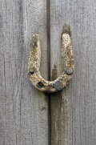Castle Farm hosted two Brown daughter Weddings in the space of 6 months. The first held in the depths of winter in a PapaKata marquee. The second a mid-summer wedding held in the stone barn. The family had such an enjoyable time and were delighted with the response from the guests that attended. It made sense to put Rebecca’s background of co-ordinating events to good use, and welcome others to the farm.

**The Facilities**

The space comprises of the beautiful stone barn, perfect for a sit down banquet or buffet. The space also allows for evening entertainment and suitable room to party.

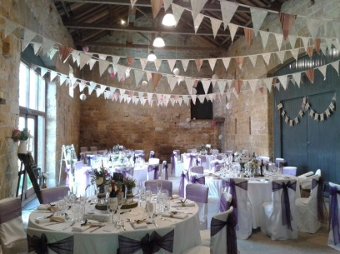

The brick Roundhouse is the ideal space for reception drinks and is the best place to home a bar. Later on the Roundhouse can also be used as a break out or quiet area.

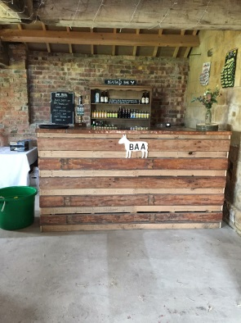

Luxury toilet facilities (with disabled access) are located onsite with an original farmhouse stone sink. Meaning no further loo hiring is required.

A small kitchenette area for caterers, with the provision of additional space for catering requirements is also provided.

The farm also has plenty of parking and outdoor space with a seasonal changing backdrop ideal for photographs.

Castle Farm provides a space that is a rustic blank canvas. It offers a venue that will be unique with perfect scope for a personalised and tailored venue to suit all tastes.

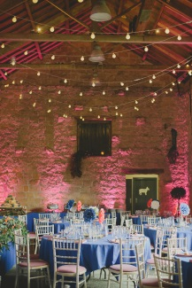

Castle Farm understands that everyone is individual and event requirements are very personal, and will work with you to create the perfect day.

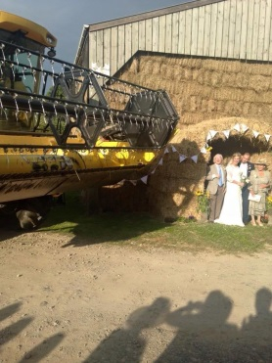

Please visit the contact page to request further information and to arrange a visit.